**Milestone 3 Report**

Authors: Kian Frassek, Cameron Clark and Thiyashan Pillay

# Common Blocks:

DIY layout creator was used to draw all circuit diagrams shown below.

# Table of figures

Figure 1: Vero board Layout with labels 2

Figure 2: Key for wires 2

Figure 3: picture of Vero board 3

# Schematic of board with labels

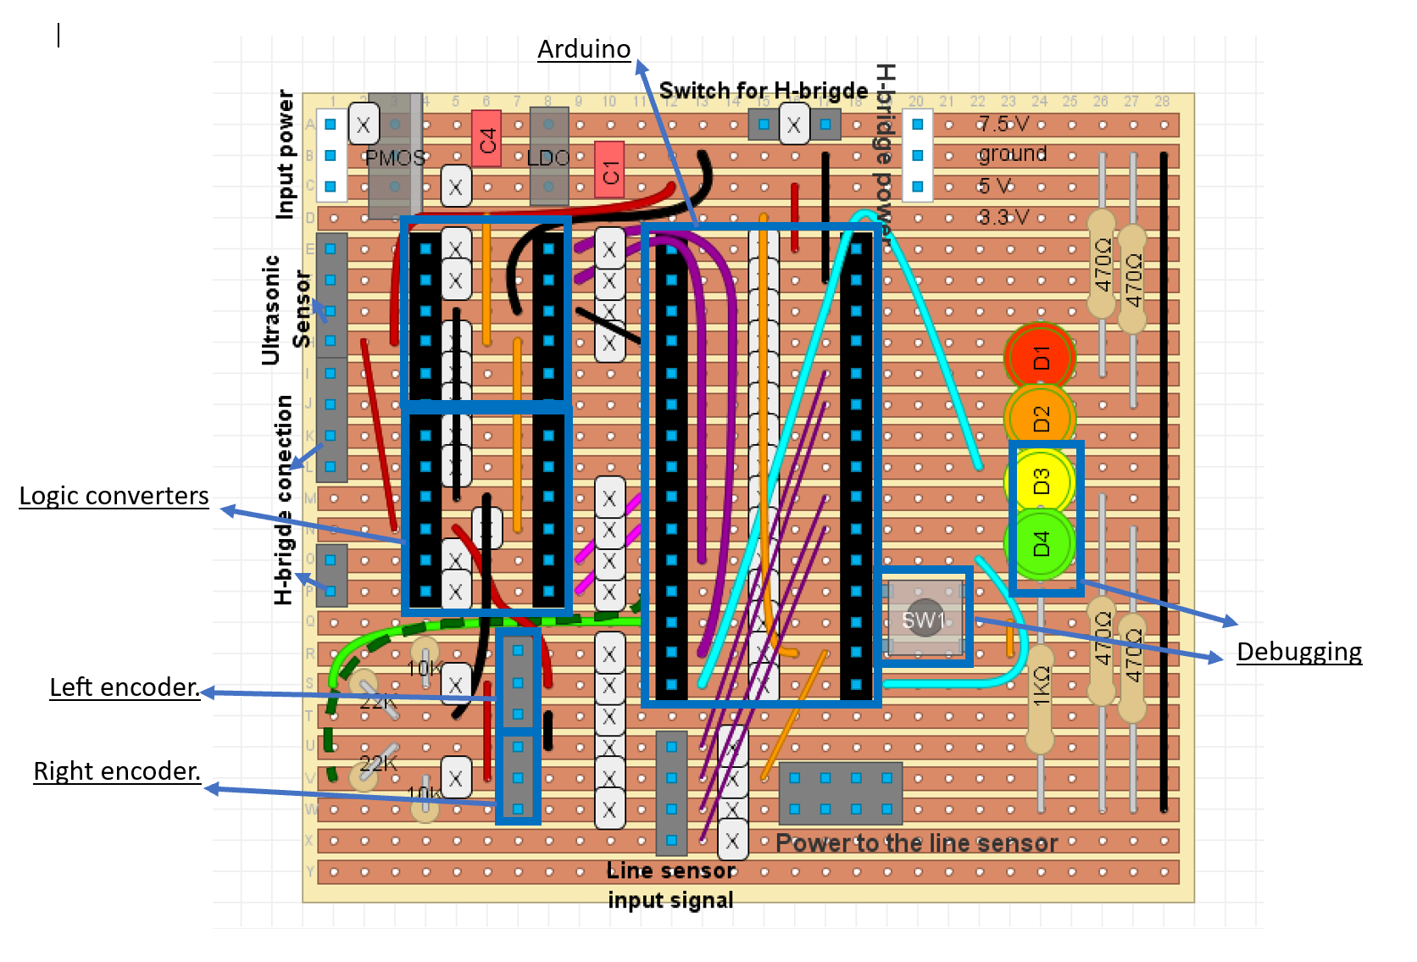

Figure 1: Vero board Layout with labels

## Key of the wire colures:

|  |  |  |  |
| --- | --- | --- | --- |
|  | | Light blue | LED to Arduino connection |
|  | | purple | Line sensor to Arduino |
|  | | pink | Arduino to logic level converters (for H-bridge connection) |
|  |  | Green (light and dark) | Use to connect the Arduino to the encoders. |
|  | | Black | Ground or 0V |
|  | | Dark red | 5V from LDO |
|  | | Orange | 3.3V from Arduino |

Figure 2: Key for wires

# Picture of board

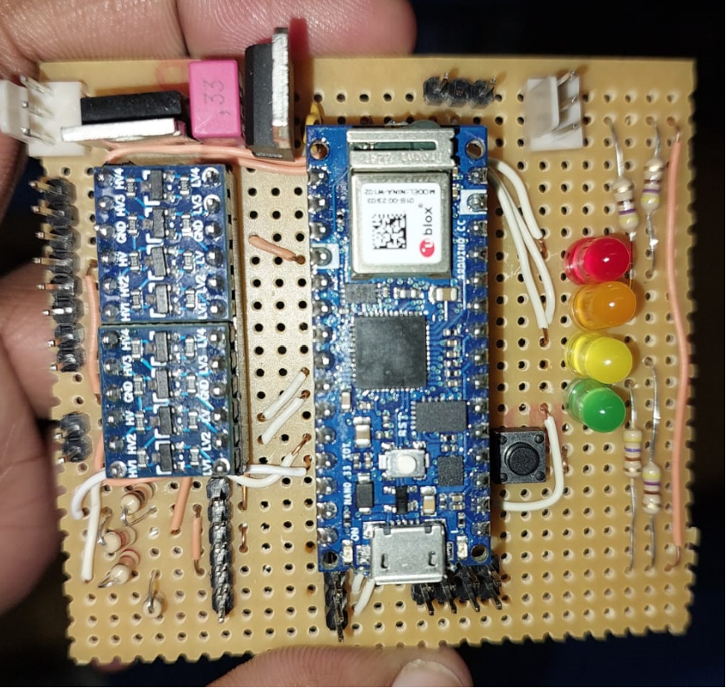

Figure 3: picture of Vero board